1. Using Scheme diagram, Create tables by properly specifying the primary

keys and the foreign keys.

create database Supplier_Database_CS154;

USE Supplier_Database_CS154;

CREATE TABLE SUPPLIER (sid int primary key,

sname varchar(20),

city varchar(20));

CREATE TABLE PARTS(pid int primary key ,

pname varchar(20),

color varchar(20));

create table CATALOG (sid int ,pid int,

cost int,

primary key(sid,pid),

foreign key(sid) references SUPPLIER(sid),

foreign key(pid) references PARTS(pid));

2. Insert appropriate records in each table.

insert into SUPPLIER values(10001,'Acme Widget','Bangalore');

insert into SUPPLIER values(10002,'Johns','Kolkata');

insert into SUPPLIER values(10003,'Vimal','Mumbai');

insert into SUPPLIER values(10004,'Reliance','Delhi');

insert into PARTS values(20001,'Book','Red');

insert into PARTS values(20002,'Pen','Red');

insert into PARTS values(20003,'Pencil','Green');

insert into PARTS values(20004,'Mobile','Green');

insert into PARTS values(20005,'Charger','Black');

insert into CATALOG values(10001,20001,10);

insert into CATALOG values(10001,20002,10);

insert into CATALOG values(10001,20003,30);

insert into CATALOG values(10001,20004,10);

insert into CATALOG values(10001,20005,10);

insert into CATALOG values(10002,20001,10);

insert into CATALOG values(10002,20002,20);

insert into CATALOG values(10003,20003,30);

insert into CATALOG values(10004,20003,40);

select * from SUPPLIER;

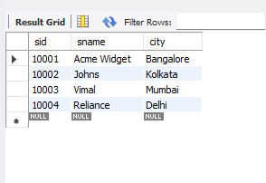

SELECT * from PARTS;

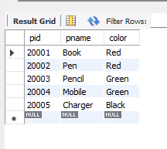

SELECT * FROM CATALOG;

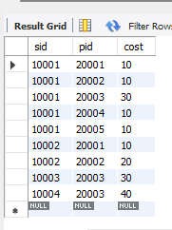

3. Find the pnames of parts for which there is some supplier.

SELECT DISTINCT pname

from PARTS p,CATALOG c

where p.pid=c.pid;

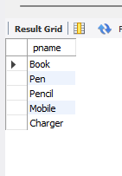

4. Find the snames of suppliers who supply every part.

select s.SName from Supplier_157 s  
join Catalog_157 c on c.Sid=s.Sid  
join Parts_157 p on p.Pid=c.Pid GROUP BY c.Sid  
HAVING COUNT(DISTINCT c.Pid) = 5;

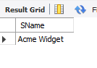

5. Find the snames of suppliers who supply every red part.

select distinct s.sname

from CATALOG c,SUPPLIER s

where c.sid=s.sid and

NOT EXISTS(select p.pid from PARTS p

where p.color ="Red" and NOT exists(select c1.sid from CATALOG c1

where c1.sid=c.sid and c1.pid=p.pid and p.color ="Red"));

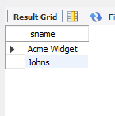

6. Find the pnames of parts supplied by Acme Widget Suppliers and by no

one else.

select p.pname

from PARTS p ,CATALOG C,SUPPLIER s

where p.pid =c.pid and c.sid=s.sid and s.sname="Acme Widget"

and NOT EXISTS (select * from CATALOG c1,SUPPLIER s1

where p.pid =c1.pid and c1.sid=s1.sid and

s1.sname!="Acme Widget");

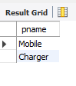

7. Find the sids of suppliers who charge more for some part than the average

cost of that part (averaged over all the suppliers who supply that part).

select distinct c.sid from CATALOG c

where c.cost>(select avg(c1.cost)

from CATALOG c1 where c1.pid = c.pid);

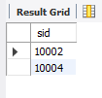

8. For each part, find the sname of the supplier who charges the most for

that part.

select p.pid ,s.sname

from PARTS p,SUPPLIER s,CATALOG c

where c.pid=p.pid and

c.sid=s.sid and

c.cost=(select max(c1.cost) from CATALOG c1

where c1.pid=p.pid);

